EDHAA Spring Virtual Art Show
2021
Welcome to the El Dorado Hills Arts Association Spring Virtual Art Show. We are proud to present the work of 36 of our very talented members. A list of participants is at the end of the show.
Terri Bennett
916-367-3662 www.terriebennett.com
"Imagine Peace" Limited edition bronze Price- $1100.00
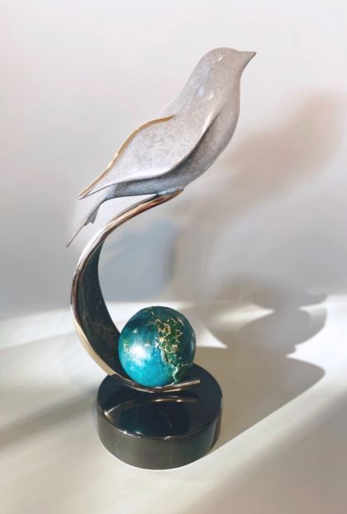

Ronald Runtenelli email: ronr1812@sbcglobal.net
Inlay bracelet- Turquoise, black jade, lapis, sterling silver The bracelet is $425. It either fits or it doesn't. Cannot be adjusted.

Sterling silver pillbox with Ocean Jasper stone 2 1/4"' X 1 3/4" X 7/8". $375 The only one on the planet.

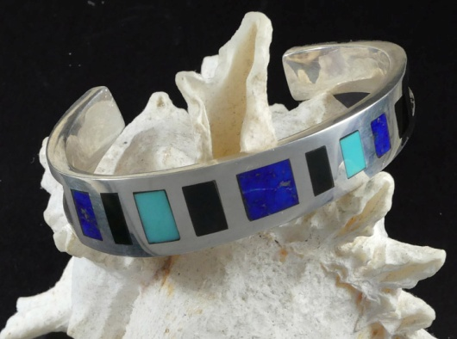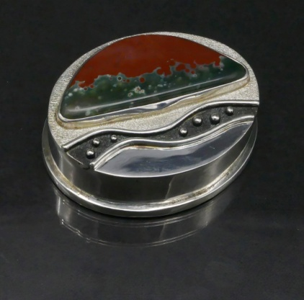

Judi Arrigotti
I bought an old shed for firewood storage for, My husband, Steve's birthday last March (early in the lockdown). Our family all agreed that, "it was ugly and stood out like a sore thumb on our property"( no matter where we put it). I assured everyone that I could camouflage it, so it would almost disappear. The whole family had suggestions about how to make it vanish, including actual camouflage greens. I knew immediately that I would paint the entire surface with a mural of the oak tree forest, with wild flowers and wild life , like the environment surrounding it.
It's a metal building, so I bought specialized canned spray paints of all the appropriate colors for painting outside and ona metal surface. My underpainting was challenging because it was a medium that I wasn't accustomed to using and the spray varied, depending on the temperature (cold in the mornings and hot in the afternoons). It was challenging, but I gained a new respect for graffiti artists. My finishing coat was when I really enjoyed the project most; I used acrylic paints with brushes, a media that I'm very comfortable using. My mural was really taking shape. In the two months it took to complete the project the trees went from bare winter branches to completely leafed out. The grasses turned from the golds and browns of winter to the greens and colorful colors of spring. While I was painting the grazing wildlife wondered through daily, so I painted the birds, wild turkeys and deer that I was seeing on a daily bases.
Everyday, my family checked in on my progress and made suggestions about what I could include, so it was definitely a shared project, which made it even more special Today, on a very gloomy, rainy day, I look out my window and see the shed where it's always spring.
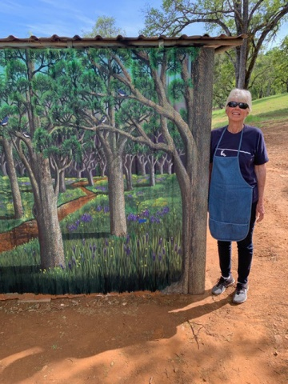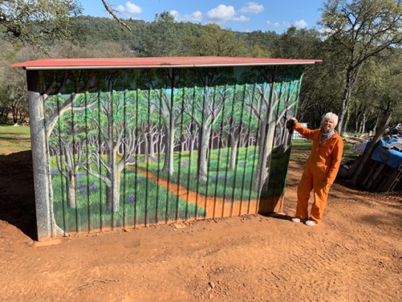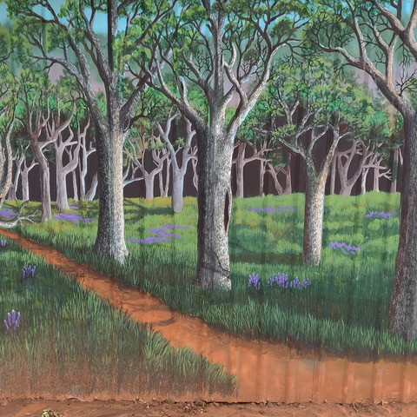

Lori Anderson
916-708-8442 lori_and@pacbell.net
Artwork Jenner at Sunset Oil 20x16 $280

We took a weekend trip to the coast and stayed on the Russian River in 2019.
At sunset all the canoes were put away for the night awaiting the next day.

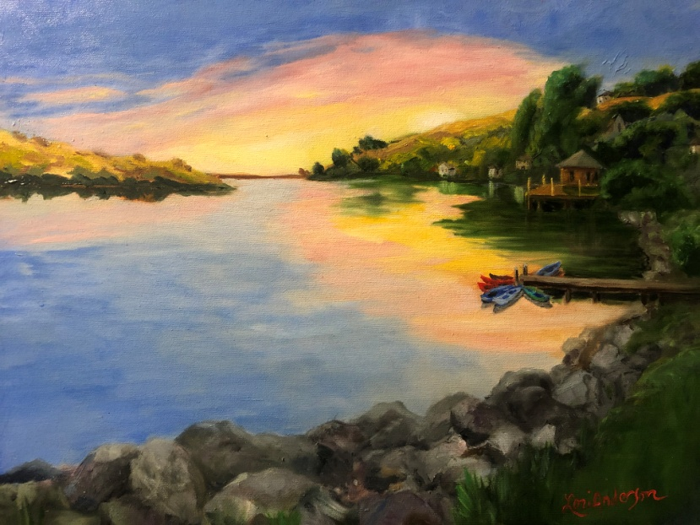
Joyce Martin
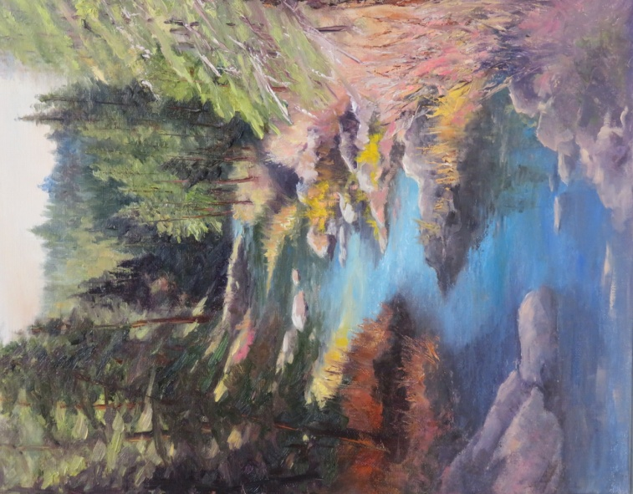

Robert Anderson

Title: Joshua Bell Unauthorized
Medium: Oil on Canvas
Size: 18x24
Price: $600
Email: Bob@ RedWillowFilms.com

The COVID19 Virus lock down encouraged me to paint more, and listen to music more. Violinist Joshua Bell is a favorite. I found a wonderful photo of him and decided to put it on canvas.

The process was the usual, putting the darker areas on the canvas first. With this painting however, that was essential to defining the space from which his passion would emerge. To me the emotion in his face was key to delivering the passion of his performance, and the sweat making his hair stick to his face showing his intensity. I also thought his hands were a key element and paid particular attention the colors and form as they held the bow and cradled the neck and strings.

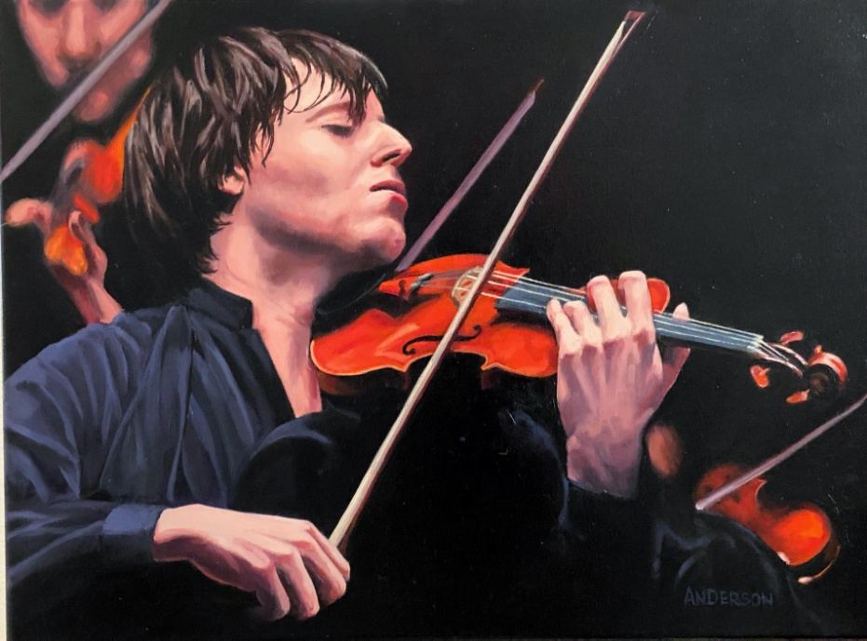

John Schaff
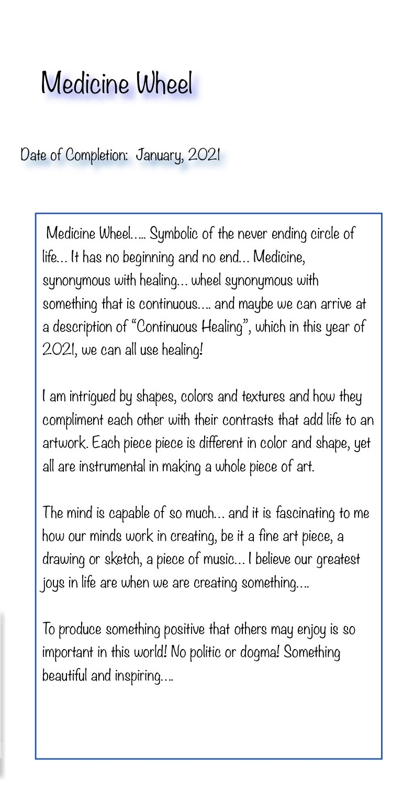

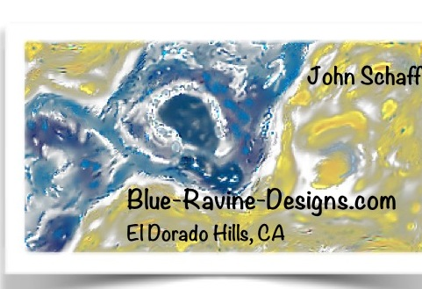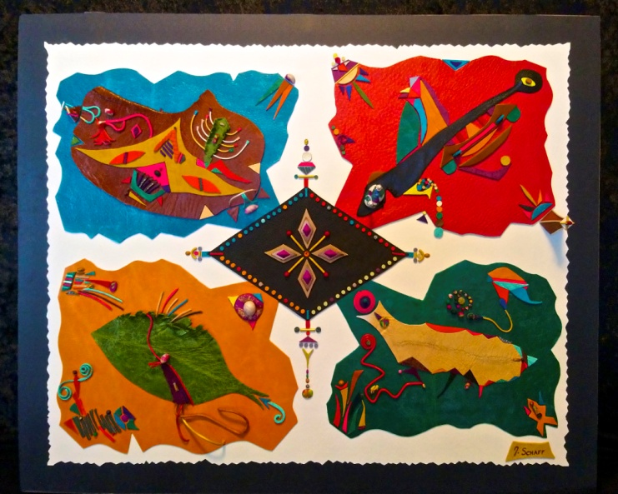

Valerie Bye
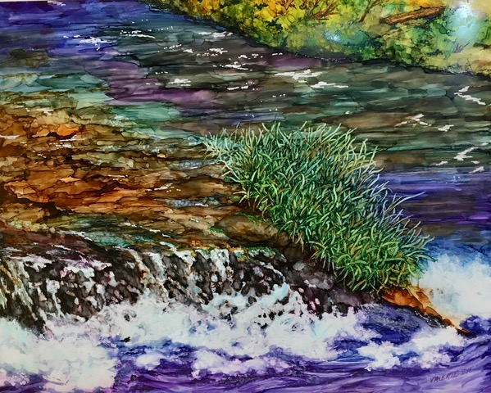

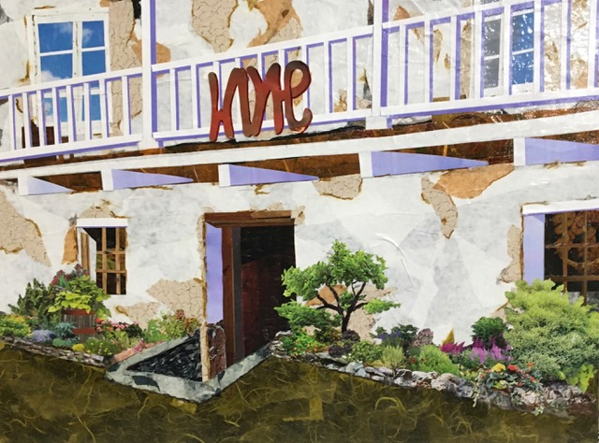

Elena Tucker
1: Just before the shutdown began last March, I was fortunate to take a class with an artist from Massechussettes. In her class, I learned her technique for making bird beads and other components. This, combined with techniques I already used, led to the creation of this necklace, Copper Bird. The bird and branch are glass and the cord is crocheted with seed beads. It is available at Art Studio 360, $120.
2: After seeing several illustrations of the covid virus, I thought one in particular looked like a bead and set out to recreate it. The process was very therapeutic, and I ended up making many of them, along with a smaller version for earrings. This necklace contains 5 of the covid beads and is $130, the earrings are $25. Both are available at Art Studio 360.

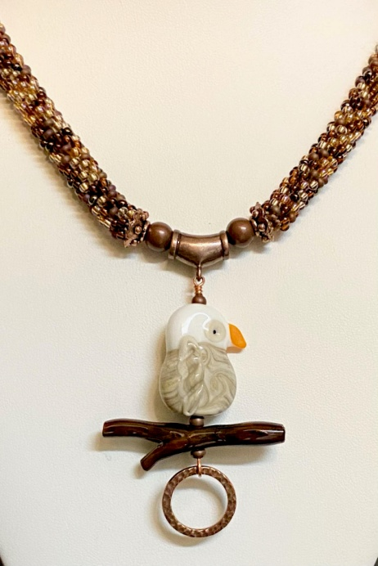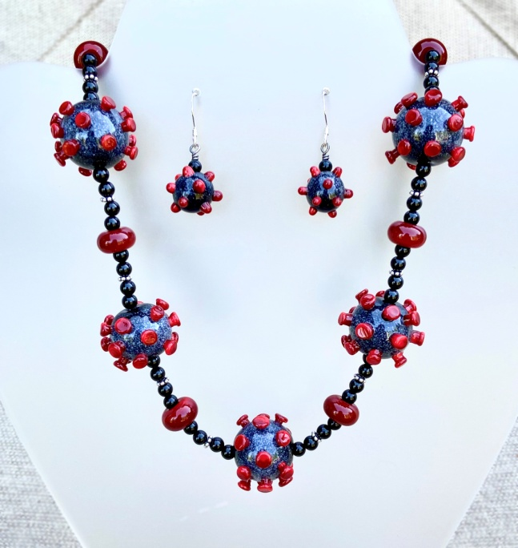

Ron Robidoux (949) 394-8790 ronaldrobidoux@gmail.com www.ronrobidouxart.com
Water Color on 300# Paper Called: My Winter Home 22”x30”
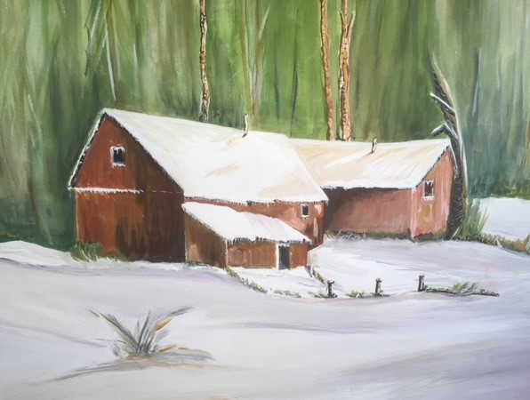
Sandy Allie: I have made a series of “Spring” figures in clay that act as a canvas for various surface decoration. Though I begin the figures in a mold that I made from an original, each sculpture created has its own expression and soul. Here, she’s dressed in zebra stripes. I love how her female form allows the animal’s stripes to roam her form and define her beauty.

Title “Spring in Zebra Stripes”
Size: 9” x 9.5” x 9.5”
Medium: Raku fired clay, clear glaze Price: $400 email: SandyAllie@sbcglobal.net

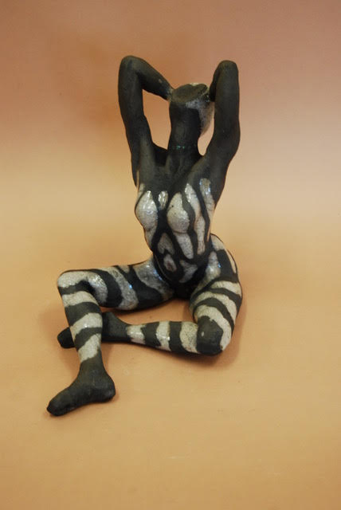

Sheri Hoeger Here is a new painting reminding me to stay calm in my “From the Top” series. Green Buddha, oil, 11x14 $400 email: sjhoeger@gmail.com
. 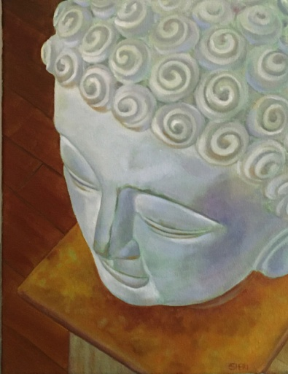

Lisa Aikenhead
"Ocean Sculptures," framed 18 x 24, for $275. Email: lisaaikenheadphotography@gmail.com

In early March 2020, I spent a week photographing along the Oregon Coast. During this time, the seriousness of the coronavirus pandemic in the United States became very clear. We were only a couple of days ahead of the closures of restaurants and beaches on the coast, and ultimately, instead of risking exposure to the virus by flying home from Portland, I asked my wife Ginny to drive to Southern Oregon to pick me up and take me home. I feel lucky that I was able to spend that week focusing on landscape photography. Every morning we'd read the latest terrifying updates about the pandemic, but then we spent the rest of the day on the beaches and clifftops, immersed in beauty, stillness, and the infinite power of nature. The meditative practice of landscape photography brings me solace and peace.

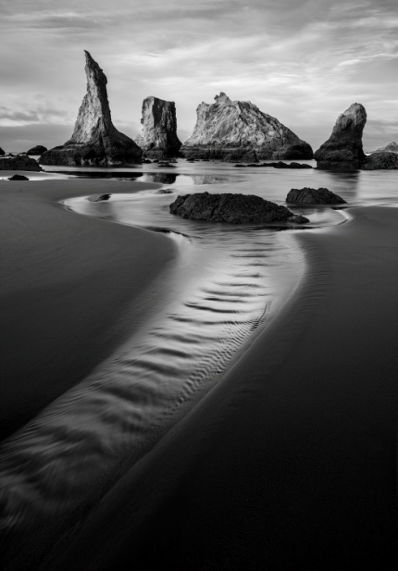

Bonita Gohler
This is a set of “Wonky Houses” I made back in July 2020. I made about a dozen of these, and sent them out to friends and family to add a bit of color and cheer during lockdown. I used a stack of very colorful monoprints I had made using my Gelli Arts Gel Printing Plate. Each house measures about 5” x 6”, and the printed paper is mounted on heavy cardstock, with a small stand in the back. I like the colorful collage and wonky angles of each one, which makes them unique and adds a touch of whimsy.
I only have one of these left, and use it to brighten up my desk.

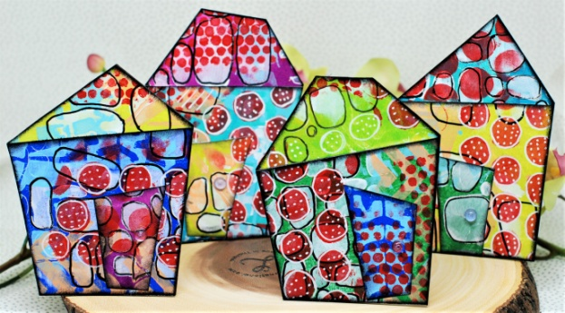

Linda Nunes
http://www.LNunesArt.com Instagram: lindanunes54 Facebook: Linda Nunes
"The Drink", 24" x 24", Oil and mixed media on cradled wood panel, $800. The work was inspired by the idea that with isolation you start to look at common everyday items in a new way. Currently at Gallery at 48 Natoma.
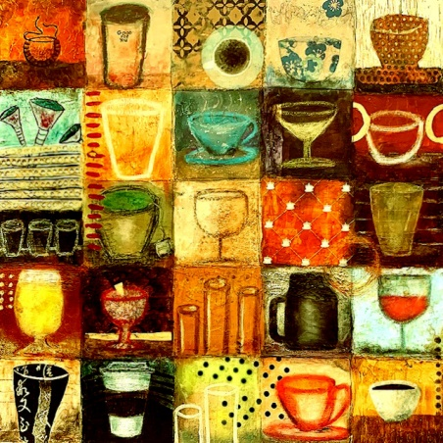

Ken Mahar
Name of image: "Dinner For One” Captured in El Dorado Hills 12’”x 18” image size, matted and framed to measure 19”x 24” fort $225 or smaller for less email: kmahar@comcast.net
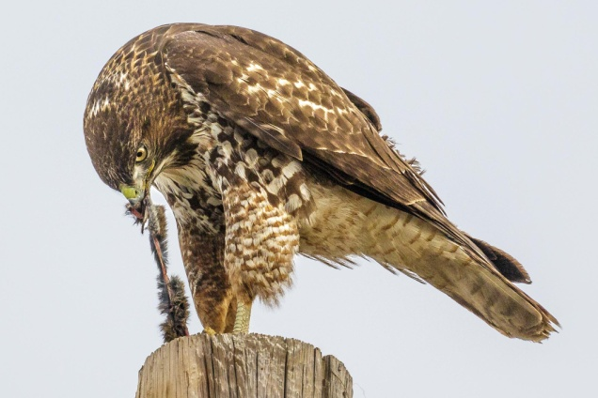
Jeannine Robb
“Portrait of 2020” I created this piece after taking a zoom workshop that focused on painting in the style of Laurel Burch. This painting is based on a “selfie" I took when we were first having to wear masks last spring. The medium is acrylic (paint and Posca paint pens) on 8”x10” canvas board. I really enjoyed painting in the bright colors and including the patterns throughout the image; very different from my typical painting style. NFS jrobbarts@gmail.com
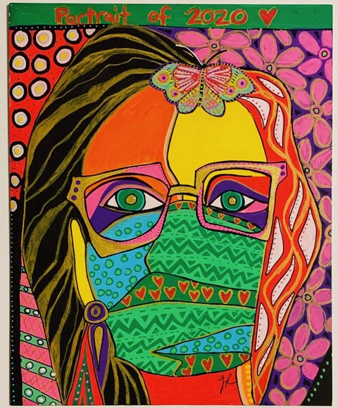
Ron Robidoux (949) 394-8790 ronaldrobidoux@gmail.com www.ronrobidouxart.com
Water Color on 300# Paper Title: My Winter Home 22”x30”

Diva Clendenin diva@liquidabstracts.com
Hyatt Dreams $175 16 x 20 Acrylic Paint on Canvas. Gallery wrapped. While sheltering in place, I was fondly remembering a recent getaway weekend that my husband and I had enjoyed in mid-February, to celebrate our birthdays. We enjoyed a couple of nights at the Hyatt Regency Hotel in downtown Sacramento, which included a glorious dinner at Dawson’s, an outstanding Blues concert by Albert Cummings at the Crest Theater, a stroll around the grounds at the Capitol, and brunch in the morning. The colors in the painting were inspired by the draperies and carpeting in the hotel, and the movement of the brushstrokes were reminiscent of the musical stylings of Albert Cummings and my dancing in the aisles!
Various brushstrokes and techniques were utilized in overlays with 5 or 6 different acrylic paint colors, including several metallics. Once fully cured, the painting was protected with a liquid varnish.
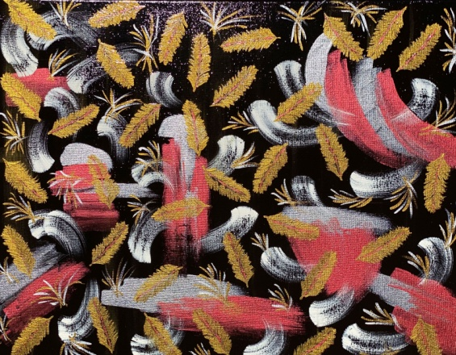
Phil Lachapelle SAN JUAN LIGHT: Original Oil, 18" x 24" on coated canvas.
This is the Lighthouse on San Juan Island located in the San Juan Islands Group in upper Washington State. I had the pleasure of visiting this beautiful place last year. Facing across Haro Strait is Victoria, B.C. Make a point to visit Friday Harbor on San Juan Island.
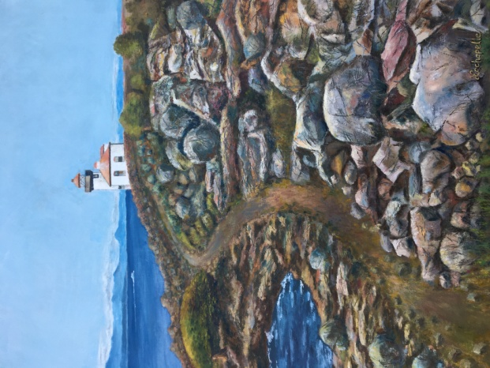
Roma Turoff All three paintings are for sale and the price will be determined if the buyer wants me to frame the painting. I can be contacted at 916 934 0176 or email Romaturoff@aol.com Three of the many paintings I have done during lock down.
The first two are from my visit to Bodega Bay before we got locked down. It was a cloudy day, but the birds were out there and so were some humans.
The third one is from a photo I took during my walk this past Fall. It is of the New York creek in EDH. I used a pallet knife to paint this scene.
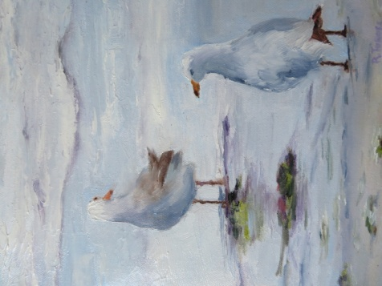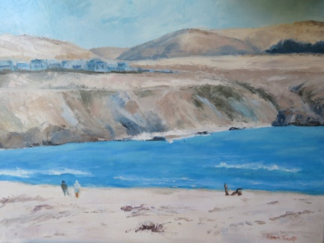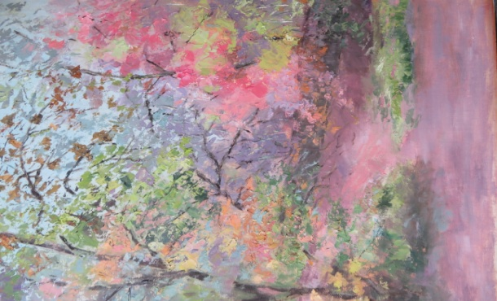

Connie Jo Hardie Title: Purple Fury Size: 22” wide x 36” tall Price $375 Website: CONNIJOHARDIE.COM
Material: Metal/Acrylic The media is acrylic paint. The bubble look is created by using a torch on the work. I enjoy manipulating the media to produce shapes and forms that in turn create new images every time you look at it. “I always see something different each time”. “Fascinating “.
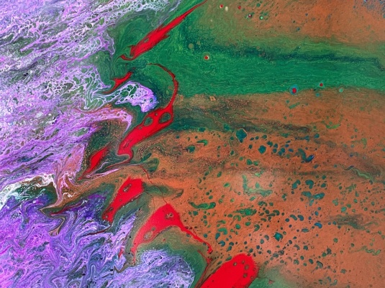
Lynn Elbert lynnelbert@gmail.com
My first try at acrylic paint pouring because I just don’t have enough hobbies.
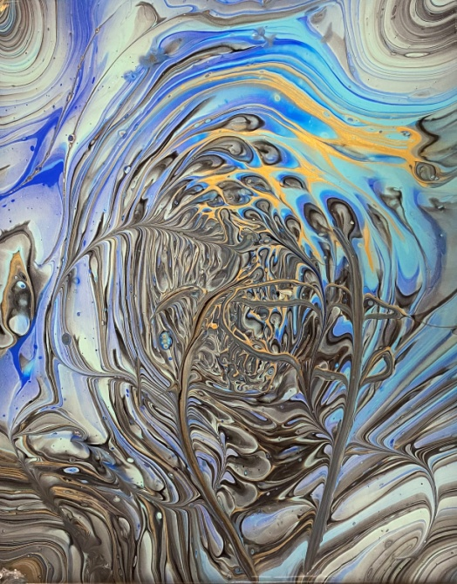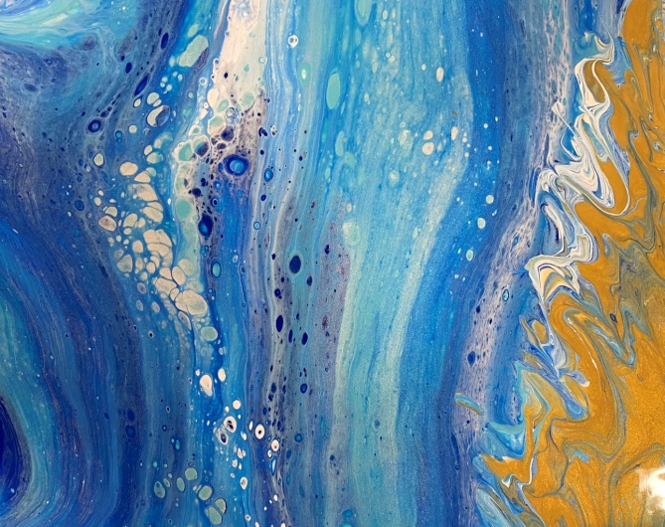

Toby Trezona Material: Wood Subject: Cougar
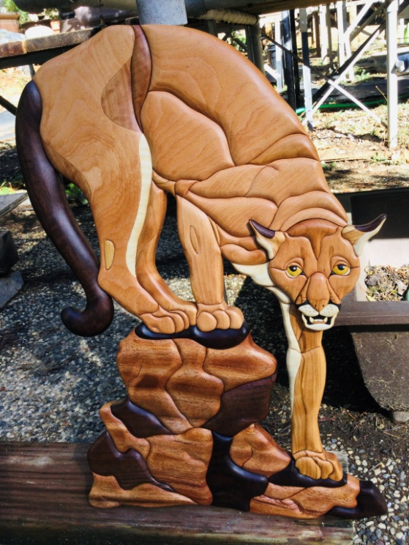

Jenny Engleson
This painting just got sold last month, I painted this flag when all the fires broke out last September. All I could do was to paint and pray because our property in Oregon was being threatened too by the 242 Fire. This Fire stopped 200 yards from our property so we got blessed. Here are some words for the Flag

Painting the Flag on the wood
This piece of wood had many splits and cracks in it.
I decided to step on it and see what comes of it. The board
split in four wavy sections.. I sanded all the edges and
realized this is a flag. As I started to paint the stars,
I only had room for 42 stars. There was a flag with 42 stars
which was produced for 8 months only in 1889-1890
time frame.
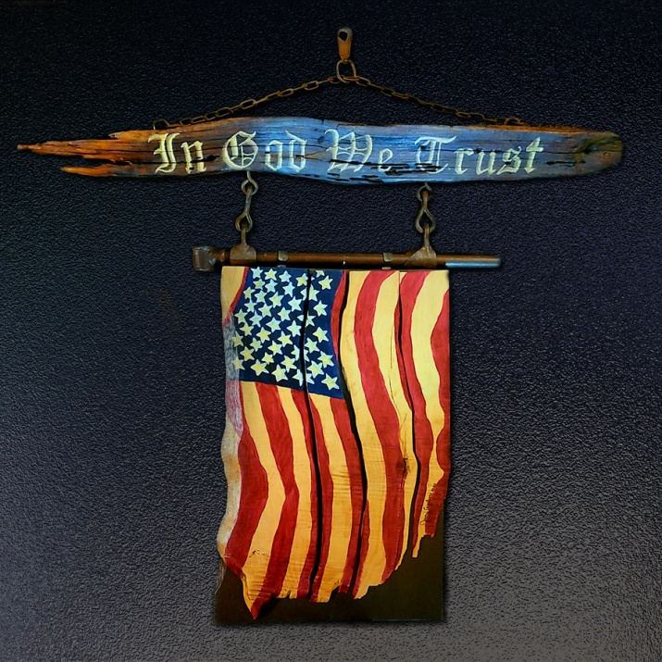
Isabella Ryder. I do woven canvas paintings in my studio. Wise woman laughs is on the right.
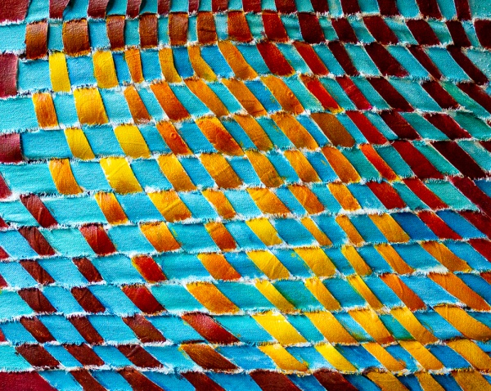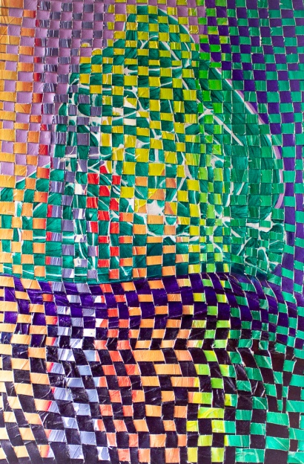

Razieh Karami Acrylic
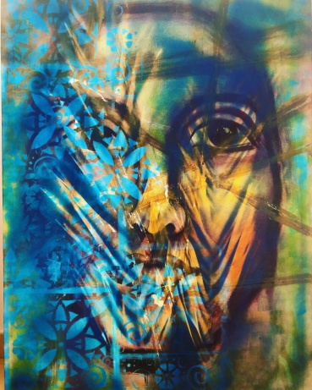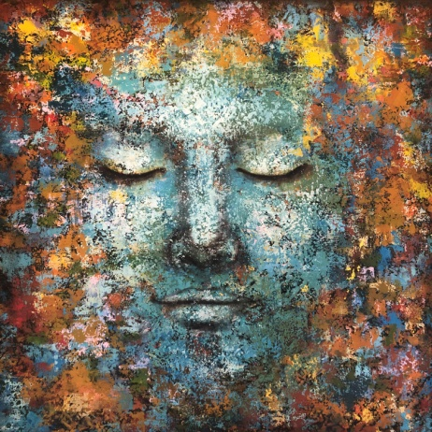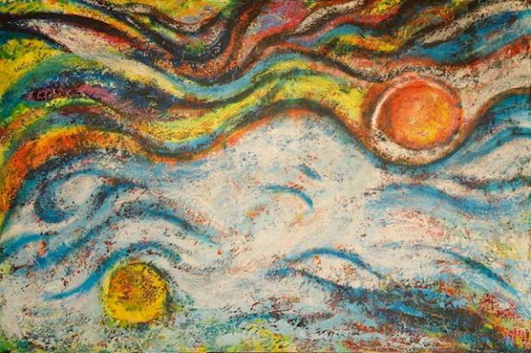

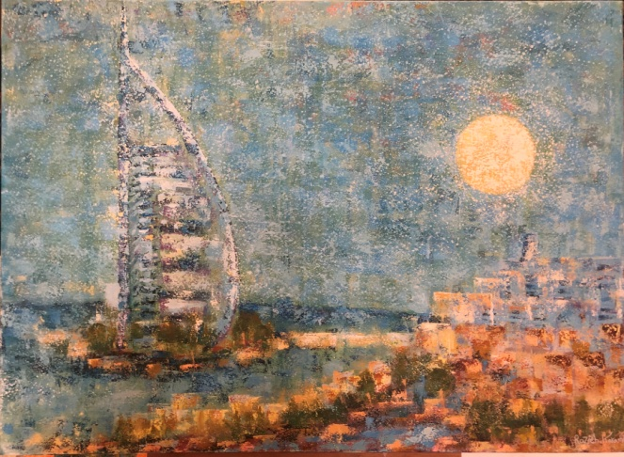
Marie Gonzales Natural Bridge, Bryce Canyon 16x20 soft pastel
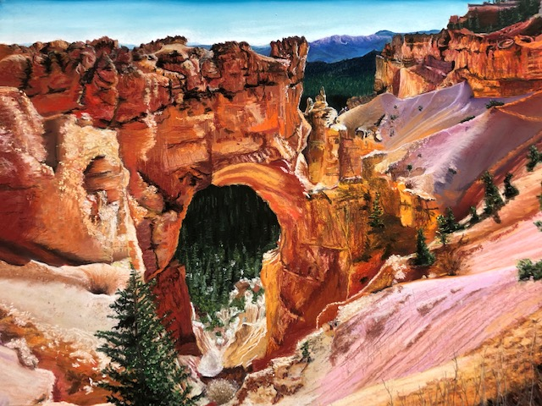

Sandy Hilton
When the pandemic began last March I thought we would be sheltering in place for a few weeks (ha!) so I thought I would use the time to work on making a dinner ware set for myself. I completed an 8 piece set but due to Covid have yet to use it with company. Maybe this March?!
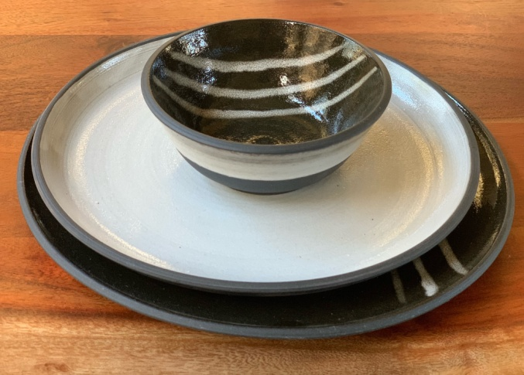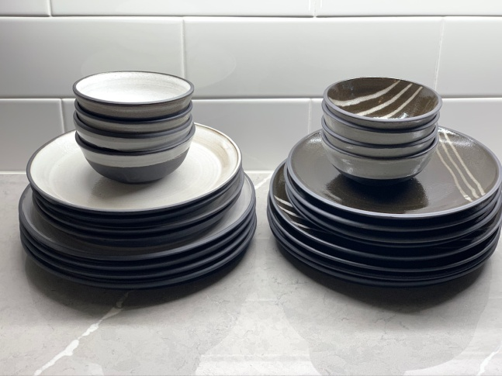

Jenny Williams
"William B. Pond, Carmichael, CA" 12x16 oil on panel

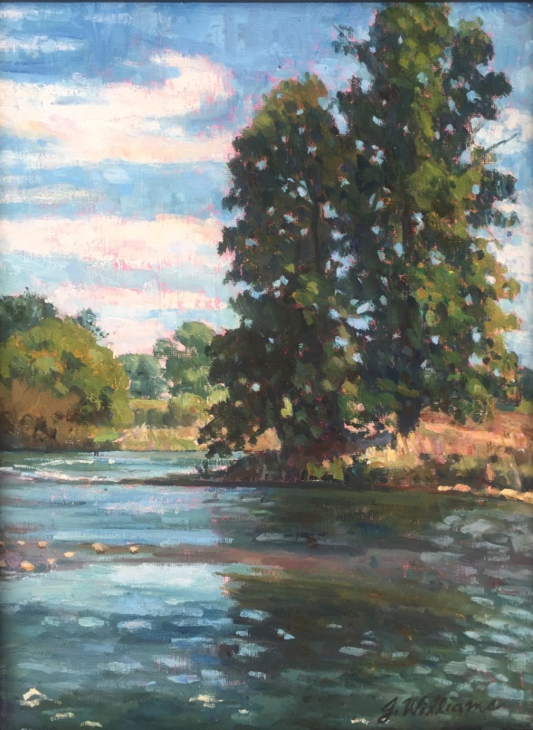

Molly Brown Roberts
This is "Prayer" Large 3x4ft. canvas in acrylic. Price: $550. mollybrownroberts@gmail.com

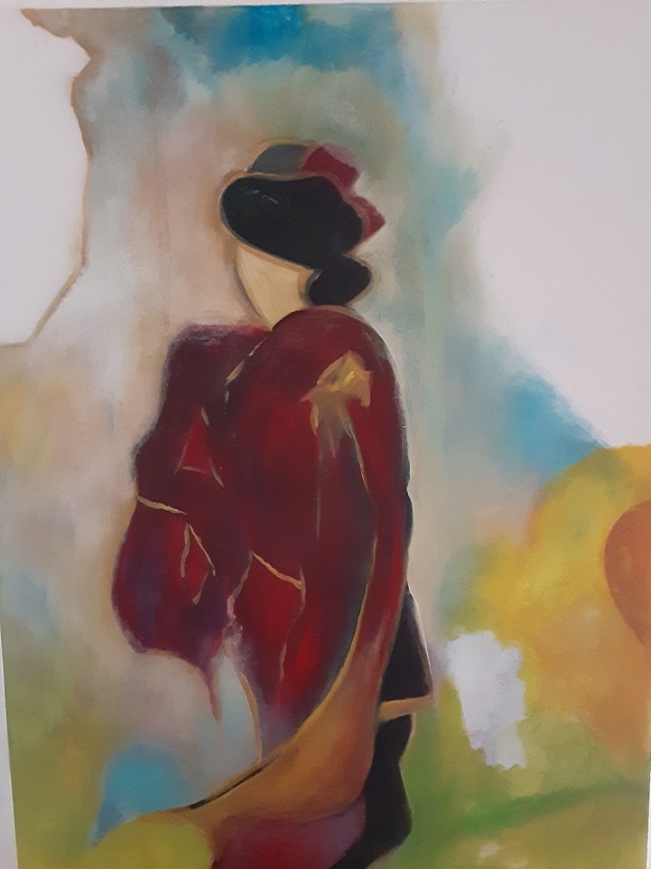

Suzanne Haydu SuzanneHaydu@yahoo.com "Eruption" an 8 by 10" image comes in a 11" by 13" black frame For Sale: $170 Watercolor with some gold acrylic, crackle texture and gesso. Eruption is my interpretation of "outbreak Covid 19".
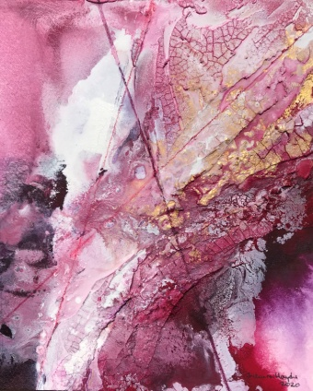
Margie Atkins Oil on canvas
My final project at the Art Center was entertainers.
On the right is Gayle, a jazz singer at our neighborhood cafe. Good times
On the left is my friend Linda also a jazz singer.

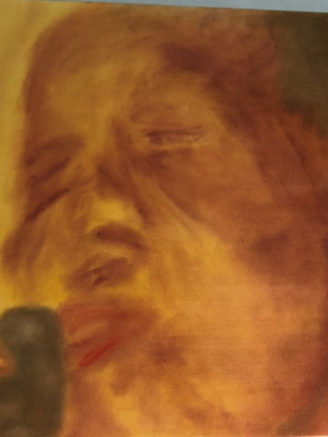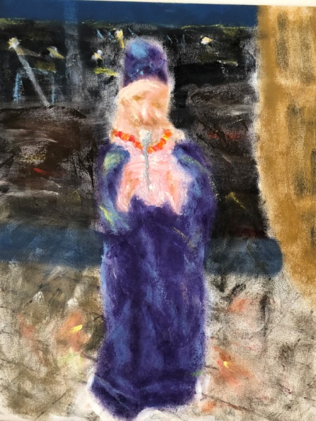

Manjiri Oak

"Dimensions"
Acrylics and Metal on Canvas
8" x 8"

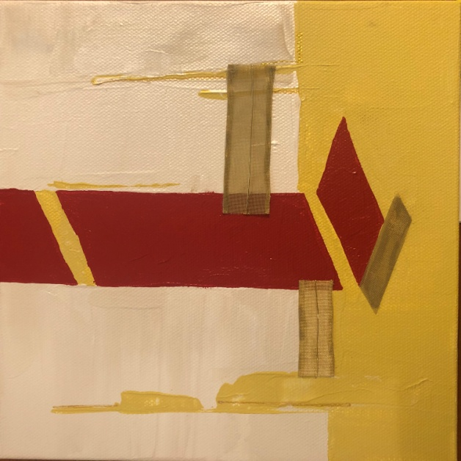

Pat Woodward Watercolor
Every year I paint a picture to use as my Christmas card. This is my 2020 picture. Because of COVID we could not celebrate with family and friends so it was a very quiet Christmas.

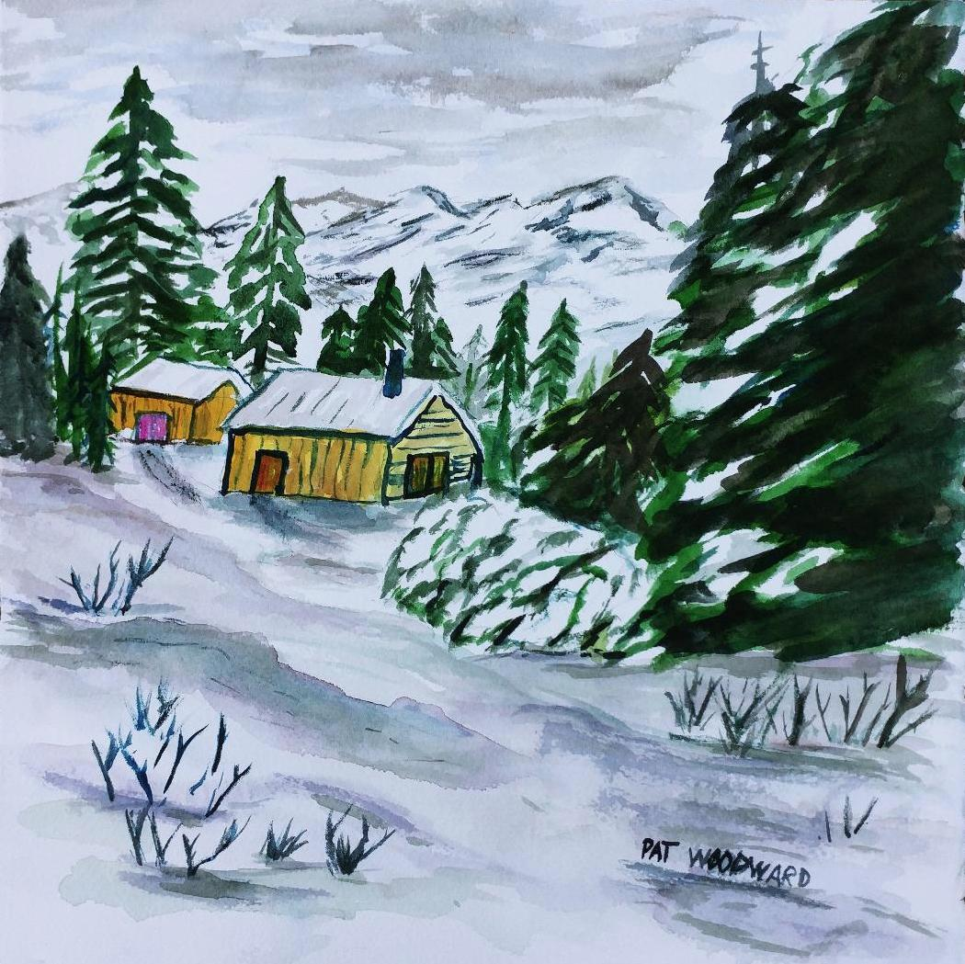

Members participating in the El Dorado Hills Virtual Spring Show 2021 (random order):
Judi Arrigotti, Robert Anderson, Valerie Bye, John Schaff. Joyce Martin, Lori Anderson, Sheri Hoeger, Lisa Aikenhead, Bonita Gohler, Linda Nunes, Ken Mahar, Jeannine Robb, Ron Robidoux, Suzanne Haydu, Sandy Allie, Elena Tucker, Roma Turoff, Connie Hardie, Diva Clendenin, Lynn Elbert, Toby Trezona, Razieh Karami, Jenny Engleson, Isabella Ryder, Sandy Hilton, Manjiri Oak, Pat Woodward, Marie Gonzales, Phil Lachappelle, Margie Atkins, Jenny Williams, Ron Runtenelli, Molly Brown Roberts, Terri Bennett, Pat Woodward

The End

